Another world is needed. Together it is possible!
by Andrew Conradi, ofs

Laudato Si’ (LS) - A call to action: sixth in a series on the 2016 World Social Forum (WSF) held in Montreal

As Pope Francis reminded us, in his statement on the 2016 World Day of Prayer for the Care of Creation, we are participants in a system that “has imposed the mentality of profit at any price, with no concern for social exclusion or the destruction of nature.” He continued: “The protection of our common home requires a growing global political consensus. Along these lines, I am gratified that in September 2015 the nations of the world adopted the Sustainable Development Goals, and that, in December 2015, they approved the Paris Agreement on climate change, which set the demanding yet fundamental goal of halting the rise of the global temperature. Now governments are obliged to honour the commitments they made, while businesses must also responsibly do their part. It is up to citizens to insist that this happen, and indeed to advocate for even more ambitious goals.”
In his statement, Pope Francis added another Work of Mercy: “So let me propose a complement to the two traditional sets of seven: may the works of mercy also include care for our common home.”
Living Christianity has always been a challenge as Bl Óscar Romero wrote in Violence of Love (p 54): “A church that does not provoke any crisis, preach a gospel that does not unsettle, proclaim a word of God that does not get under anyone's skin or a word of God that does not touch the real sin of the society in which it is being proclaimed: what kind of gospel is that?”
Does caring for refugees come under charity or justice or both? Pope Francis reminds us “There has been a tragic rise in the number of migrants seeking to flee from the growing poverty caused by environmental degradation.” (LS, 25) Already in 2008, the UN said that 20 million people were displaced because of climate change. As this number continues to grow, the necessary social, political, economic, and legal structures will need to be in place to support the migrant’s needs.
“When we ask ourselves what kind of world we want to leave behind, we think in the first place of its general direction, its meaning and its values.” (LS, 160) An example of the general direction that we might consider can be found in The Leap Manifesto. It is a bold 15 point vision for Canada, that bills itself as “A Call for a Canada Based on Caring for the Earth and One Another” which echoes the “Cry of the earth and cry of the poor” (LS, 49) As CNN Anchor Becky Anderson wrote: “In reading it, it seems like a blueprint that could be used across the world.”
The writing of The Leap Manifesto was initiated in the spring of 2015 at a two-day meeting in Toronto attended by 60 representatives from Canada’s indigenous rights, social and food justice, environmental, faith-based and labour movements. The This Changes Everything team convened the meeting but did not determine any outcomes. The idea was to create a space to not just say “no” to the worst attacks on human rights and environmental standards, but to dream together about the world we actually want and how we could get there. The Manifesto went through several drafts and was shaped by the contributions of dozens of people. Those who have signed include supporters of all the political parties, and some who support none.
Franciscan protesting at World Bank, Washington, D.C., in 2014 against a mining
company suing El Salvador for not allowing a mine on environmental grounds
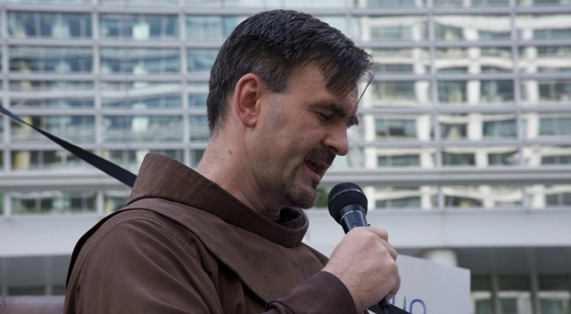

It does unsettle some people and there is the chance that those who espouse it will be called unrealistic fools. That should not surprise anyone unless they have never heard that Christian visionaries are happy to be accused of the foolishness of Christ and called fools for Christ. “It must be said that some committed and prayerful Christians, with the excuse of realism and pragmatism, tend to ridicule expressions of concern for the environment. Others are passive; they choose not to change their habits and thus become inconsistent. (LS, 217) “Obstructionist attitudes, even on the part of believers, can range from denial of the problem to indifference, nonchalant resignation …. (LS, 14)”
Our foolishness in Christ is, in fact, an expression of incarnated spirituality: a spirituality that guides people to be fully involved in human and worldly affairs as a concrete sign of commitment to building the Kingdom of God. In fact, if justice, peace and the care of creation in our common home is what some would view as foolish, then we all need to become fools. St Francis was often called Christ’s fool. If you are not a fool for Christ, whose fool are you?
My Secular Franciscan Rule (n 4) tells me to go from gospel to life. “… first strive for the Kingdom of God and his righteousness” (Mt 6:33) “The Kingdom of God is … Justice, Peace and Joy in the Spirit.” (Rm 14:17).
Or as the Episcopal Commission for Doctrine of the Canadian Conference of Catholic Bishops in The Co-responsibility of the lay Faithful in the Church and the World (23 Sept 2016) puts it: “a real commitment to applying the Gospel to the transformation of society.” (8)

Sixth in a series of articles by Andrew Conradi, ofs on the 2016 World Social Forum. The first was a general introduction and touched on lifestyle and values, followed by mining, climate change, agroecology, Laudato Si’ and political charity. This and the final one covers why we need to act and what we can do to help bring about the necessary changes to implement Laudato Si’.

