Another world is needed. Together it is possible!
by Andrew Conradi, ofs

On Mining: second in a series on the 2016 World Social Forum (WSF) held in Montreal

Why has the church long been concerned about mining? The grave impact of extractive industries on the environment and human rights is nothing new and leads to continual protests against certain forms of extractivism.

Growing brutality in the repression of social protest faced by local communities affected is exemplified by the assassination of Berta Cáceres and her colleague in Honduras in March 2016 and are extreme but not uncommon examples of such abuse.

The church’s concern has been given new impetus by the strong voice of Pope Francis in Laudato Si’ and the growing concern of the Pontifical Council for Justice and Peace and many bishops and civil society around the world.

There is clear evidence that mining companies care more about profits than the environment and human rights, and that governments serve the companies rather than the people they were elected to serve. The laws governments pass and their weak ineffective efforts to protect the environment and human rights reflect that. In Canada we call such governmental agencies “captured agencies.” At the WSF in Montreal this summer Franciscans focused on three cases from among the many.

In Marikana, South Africa in 2012, 112 protesting miners were shot and 34 killed. Those who may find themselves accused of colluding in the police action include senior figures from the government and the British company that owns the platinum mine. This provides a clear example of corruption and the “capture” of governments, police and company security forces and the miners’ union. Protesters are criminalized for defending human rights and calling for equity in sharing the profits.

At Mount Polley, BC on 4 Aug 2014, the copper and gold tailings dam at Imperial Metals’ mine collapsed, resulting in a toxic spill of 24 million cubic meters of mine waste. Luckily no lives were lost but it affected drinking and irrigation water. The long term damage to the environment and especially the salmon fishery, essential to First Nations and others along the Fraser River, is not yet fully known but can be imagined.

On 5 November 2015, an even bigger toxic spill occurred when a mine tailings dam collapsed in Mariana, Brazil at the Samarco iron mine. A toxic wave travelled 800 km down the Rio Doce to the South Atlantic. The tragedy took 19 lives, left 1,200 homeless and thousands more with loss of land and livelihoods.

In both the Mt Polley and Rio Doce mine dam collapses, the companies had received earlier warnings but failed to act and so the question of government monitoring of safety standards and consequent criminal negligence, both government and corporate, has been raised. As Rodrigo Perét, a Franciscan presenter, explained, the governments are predatory, exploitive, corrupt, destructive, complicit and compliant in the immunity and impunity of the companies.

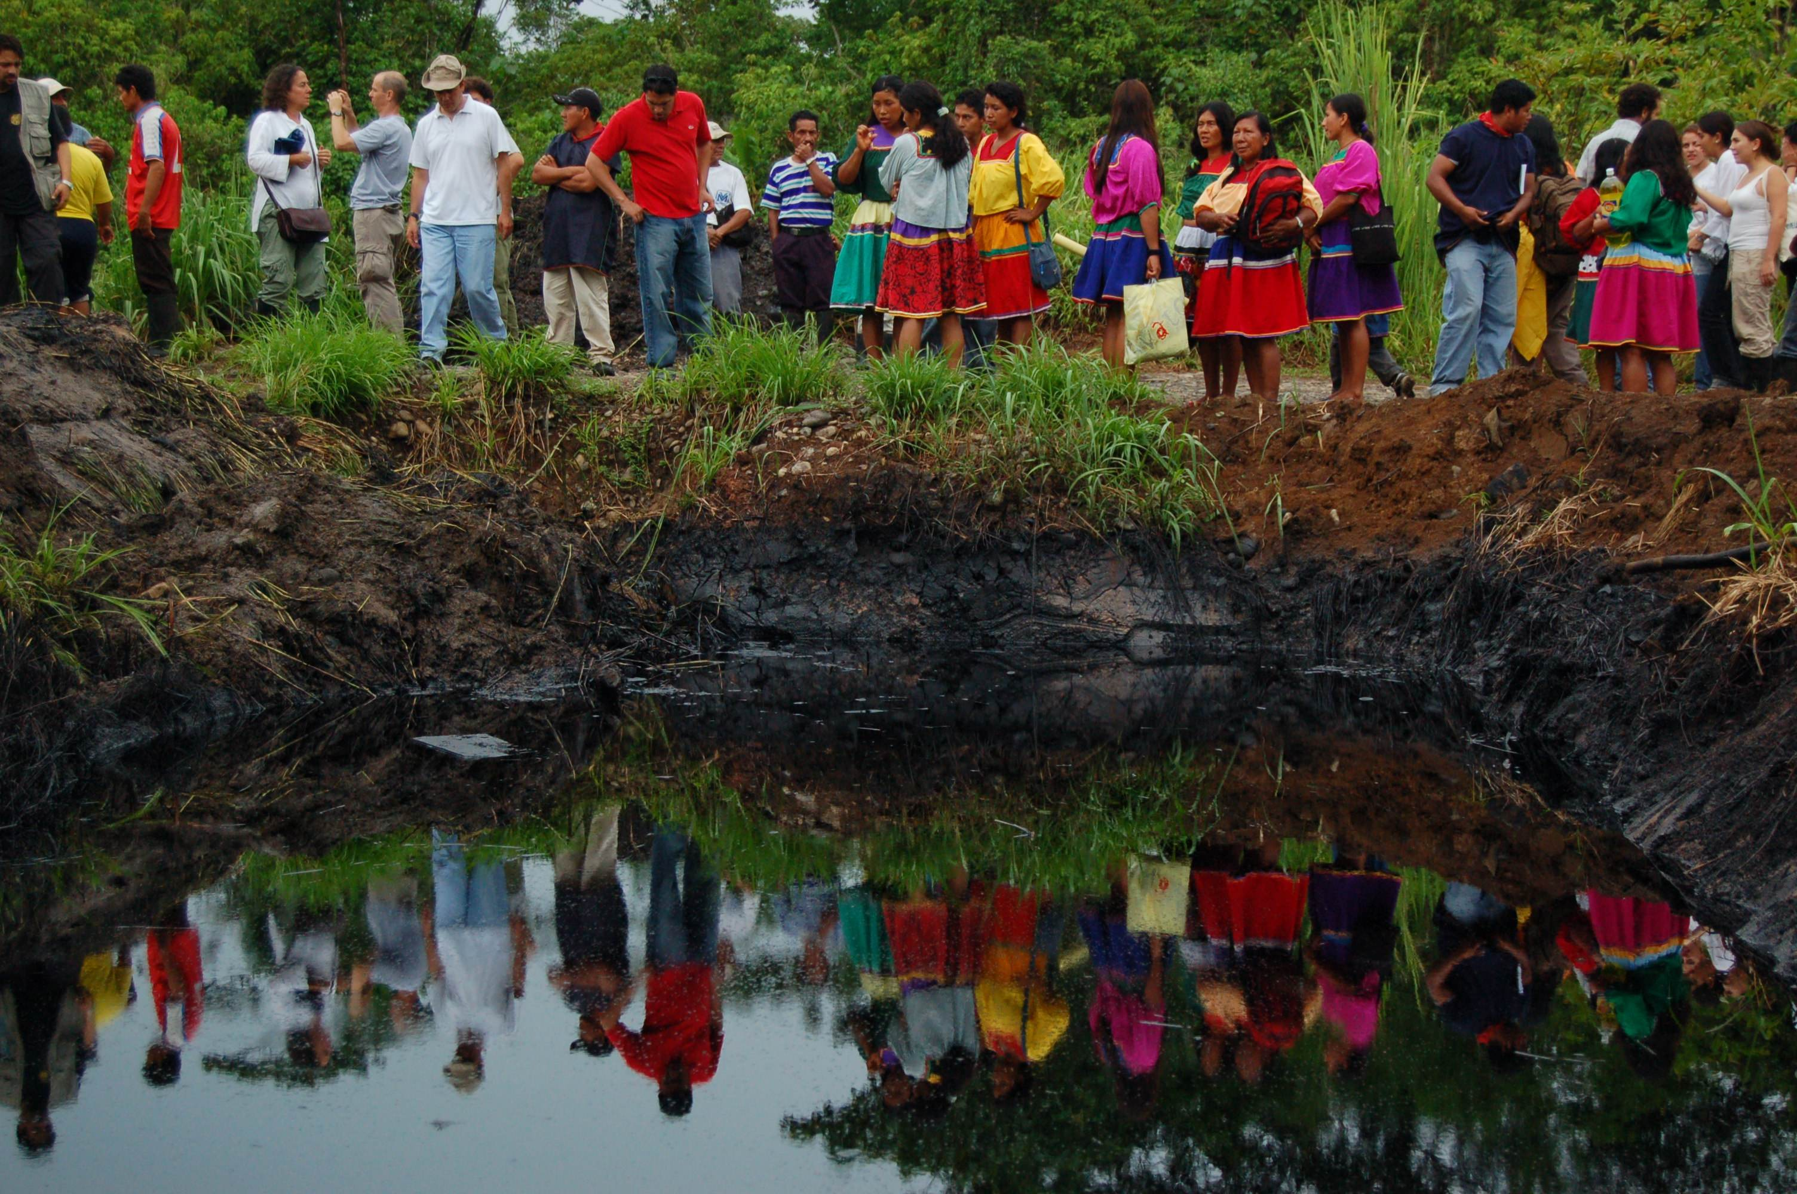
Oil pollution in Ecuador (MiningWatch Canada)

Governments award concessions to mining companies. Villages are displaced, fields and streams are contaminated and the communities have no say. Communities are resisting and are demanding one thing: that their right to free, prior and informed consent be respected yet they are treated as criminals. Are not the companies the real criminals and getting away with their crimes? Yet it is the protesting victims who are arrested and beaten.

In terms of corporate responsibility for human rights, and social and environmental issues, there is a huge gap between declared corporate intentions and actual corporate behavior. The local people affected by the company’s actions therefor do not trust the companies. Given the governments’ complicity the people do not trust the governments either. History shows that only persistent persevering public pressure can bring about any change in corporate and governmental behavior. Is there a lesson in that for us on what we should do? Agreements that are mere corporate propaganda are not worth the paper they are written on and are simply not good enough. How do we hold corporations accountable for their actions and make them live up to accepted standards? How do we make governments enforce accepted standards?

Second in a series of articles by Andrew Conradi, a Secular Franciscan. The first was a general introduction and touched on lifestyle and values. Following articles will deal with climate related issues and suggestions on what we can do to bring about change.

