Another world is needed. Together it is possible!
by Andrew Conradi, ofs

First in a series on the 2016 World Social Forum held in Montreal: General Introduction

Does the headline sound like something Pope Francis wrote in Laudato Si’: On care for our common home? Actually the headline was the slogan for the World Social Forum (WSF) held in Montreal 9-14 August.

As McGill economist Henry Wintzberg said: “The World Economic Forum [WEF held in Davos, Switzerland] gets enormous press coverage. The WSF has barely received mention in its host city, let alone around the world. … the WSF is about change in the face of power.”

More than 35,000 people from 125 countries attended. The WSF has Catholic links and is strongly supported by many Catholics including bishops.

We need a vision of the just world we wish for: "Where there is no vision, the people perish."(Proverbs 29:18). Who can provide that vision? If another world is needed, what might it look like? We know what we are against; we need to propose what we want. That is what WSF 2016 was about.

I attended the WSF with the international Franciscan Family delegation. As Ilia Delio, osf has said: “The Franciscan path “to God … is to be found in the world. The idea that “the world is our cloister” finds its root in Francis of Assisi.”

Pope Francis adopted integral ecology and says that Francis of Assisi was: “ … a pilgrim who lived in simplicity and in wonderful harmony with God, with others, with nature and with himself. He shows us just how inseparable the bond is between concern for nature, justice for the poor, commitment to society, and interior peace.” (LS, 10) He adds “: … we ourselves are the dust of the Earth; our very bodies are made up of her elements, we breathe her air and we receive life and refreshment from her water.” (LS, 32).

Michael Perry, OFM wrote that: “The deepest motivation of Franciscan ecological commitment, following in the footsteps of Francis, is a theological motivation; God is recognized as the Creator of everything, something which demands respect for God’s creation, which he has given to all, and not just to some.” He continued: “the sisterhood and brotherhood intuited and experienced by Francis of Assisi is not just a human reality, it is also cosmic: it extends to every creature and expresses a universal bond of brotherhood and sisterhood that comes from the simple fact of having a shared Creator and Father, who is God.”

Perry called on Franciscans “to reassess their manner of perceiving and acting, and to restructure their lifestyles in order to allow the Spirit of God to fashion within each of us an ‘integral ecological vision’ that embraces all, in charity and justice. May we allow God to work the wonderful mystery of love and mercy within us so that we might remove the obstacles that deafen us to the Cry of the Earth and the Cries of the Poor. … We must start from a spirituality immersed in the world, feeling ourselves a part of the cosmos, as well as part of the problem. Otherwise we may end up always seeing the crisis as something far removed from our lives, even when its effects come close to home.”

I was one of two Canadians in the Franciscan delegation, which came from 11 different countries. While the main Franciscan focus was on lifestyle, mining and the green economy it also included Laudato Si’, climate, extreme poverty and Fair Trade. Lifestyle embraces a broad set of behaviors: to quote the Holy Father in Laudato Si’ (211): “avoiding the use of plastic and paper, reducing water consumption, separating refuse, cooking only what can reasonably be consumed, showing care for other living beings, using public transport or car-pooling, planting trees, turning off unnecessary lights, or any number of other practices” such as reduce, reuse, recycle; Fair Trade; use of tap water and against privatization of water; promotion and use of solar energy; eating local real food; and cutting down on materialism and consumerism.

First in a series of articles by Andrew Conradi, a Secular Franciscan. Following articles will deal with mining; climate and agriculture and finally what we can do.

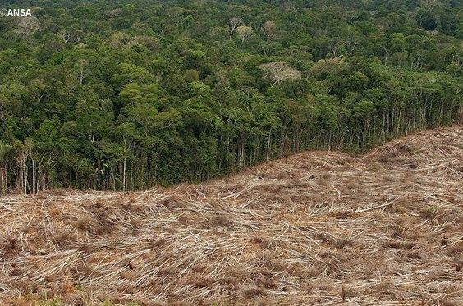
The Brasilian Bishops’ Pastoral Land Commission denounce growing deforestation in a “land without law, where everything is permitted.” 22 August 2016

